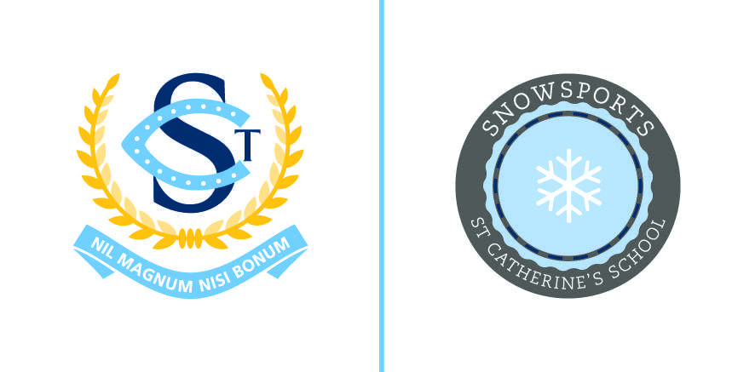

Nomination to Snowsports Auxiliary
Executive and General Committee

I, ______________________________, being a parent of St Catherine’s School nominate
fellow parent; ________________________________ for election to the 2024 Snowsports Auxiliary as:

◻ President
◻ Vice-President
◻ Treasurer
◻ Secretary
◻ Committee Member

Signature ________________________________
Date ________________________________
I, ______________________________, being a parent of St Catherine’s School
second the nomination as noted above

Signature ________________________________
Please complete the nomination form and send to the following email address by no later than
Friday 10 November 2022:

Julia Soutter
Snowsports President
0400 229 625

